[www.crjfr.org](http://www.crjfr.org)



* **Click on « CONNEXION »**

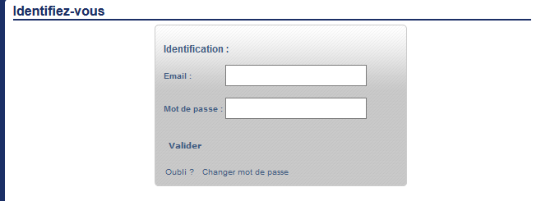

**Email :**

**Mot de passe :**

* **Click on « OK »**

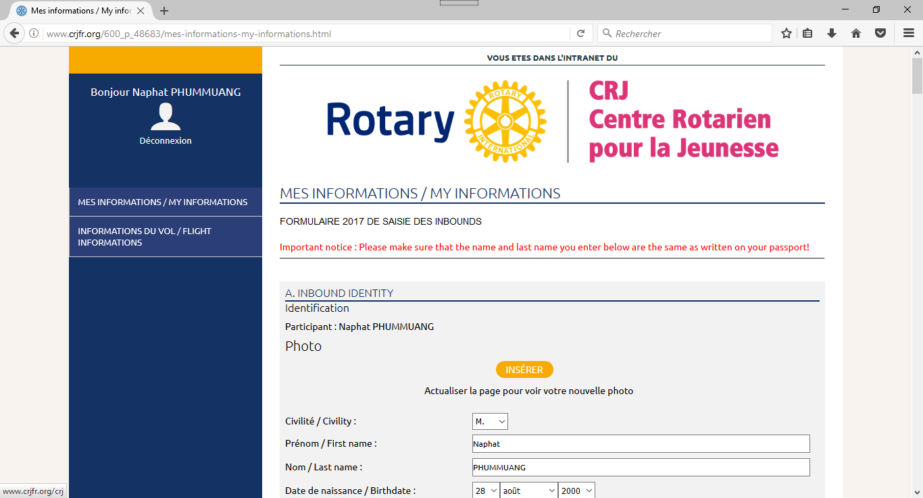

* Add your photo: click on « Insérer »
* Verify your identity name, last name, birthdate: exactly the same as your passport. Correct if need be.
* Fill the form with your data, you can complete fields from 3 to 27..

If you are missing some information, you’ll be able to complete the form later.

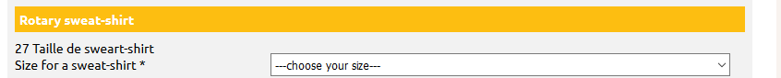

**Be careful: always save before closing. At the bottom of the web page, click on “Valider”**

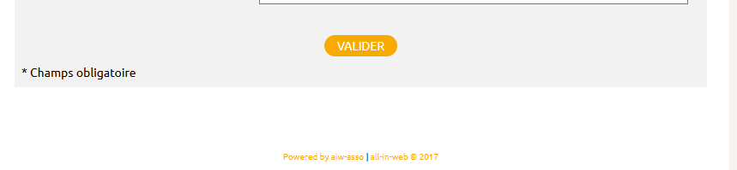

**We (district 1670) will fill fields from 28 to 127.**